PHENIKAA UNIVERSITY

PHENIKAA SCHOOL OF COMPUTING



COURSE: SOFTWARE ARCHITECTURE
HOTEL MANAGEMENT SYSTEM

INSTRUCTOR: Vũ Quang Dũng
GROUP 7: Trần Ngọc An (23010283 – K17-KTPM)
CREDIT CLASS: CSE703110-1-2-25(N01)

Ha Noi, March 6, 2026
Contents
1. Executive Summary 3
2. Architectural Design & Implementation 3
2.1 Architectural Pattern & Layers 3
2.2 Technical Stack and Data Model 12
2.2.1 Data Relationships 13
2.2.2 Key State Models (Status Transitions) 19
2.2.3 API Endpoint Catalog (Core Contracts) 21
2.2.4 Authorization Matrix (Role-based Access Control Summary) 23
2.3 Implementation: Server-Side Logic (Flask Backend – Controllers/Services) 24
2.3.1 Key Validation & Error Handling Strategy 26
2.3.2 Runtime/Deployment View 27
2.4 Implementation: Client-Side Logic (Web UI – HTML/CSS/JS) 28

1. Executive Summary
This project implements a Hotel Booking Management System that supports the end-to-end workflow of a real hotel: customers can browse rooms, create bookings, make payments, manage their wallet, and view booking history; receptionists can check guests in and out and manage service requests; administrators can manage rooms, services, staff, coupons, and reports. The system is architected using a layered architecture on top of Flask, with clear separation between controllers (HTTP layer), services (business logic), repositories (data access), and models (domain entities).
The backend lives under SRC/Arch and exposes REST-style JSON APIs (e.g. /api/bookings, /api/rooms, /api/auth/login, /api/wallet) through controller classes such as booking_controller.py, room_controller.py, user_controller.py, payment_controller.py, coupon_controller.py, checkin_controller.py, staff_controller.py, report_controller.py, and wallet_controller.py. These controllers rely on service classes (e.g. booking_service.py, room_service.py, payment_service.py, coupon_service.py) that encapsulate business logic and call repository classes (e.g. booking_repository.py, room_repository.py, coupon_repository.py) to access a MySQL database.
The frontend is implemented in SRC/UI as a set of HTML/CSS/JS pages for different roles: public pages for browsing rooms, authentication pages for login and registration, user pages for dashboard, my bookings, payment, and wallet, and admin pages for room and staff management and reports. The final outcome is a working multi-role hotel management application where the architecture supports modifiability, maintainability, and basic security and scalability for small-to-medium usage.

2. Architectural Design & Implementation

2.1 Architectural Pattern & Layers
The backend follows a layered architecture on top of Flask:

- Presentation/API Layer – Controllers (SRC/Arch/controllers): booking_controller.py, room_controller.py, user_controller.py, service_controller.py, payment_controller.py, coupon_controller.py, checkin_controller.py, staff_controller.py, report_controller.py, wallet_controller.py.

These classes receive HTTP requests (via routes defined in app.py), parse and validate incoming JSON, call appropriate service methods, and use View classes (e.g. booking_view.py) to format the JSON responses.

- Business Layer – Services (SRC/Arch/services):
- booking_service.py handles booking lifecycle: create_booking, update_booking, cancel_booking, get_user_bookings. It validates input, checks dates, consults room_service.py for availability, interacts with room_repository.py to reserve rooms, and optionally triggers payment_service.py for immediate payment.
- coupon_service.py validates coupon creation and apply_coupon logic, enforcing rules on discount types, values, and validity dates.
- Additional services such as room_service.py, payment_service.py, checkin_service.py (if present), report_service.py, staff_service.py, user_service.py, and wallet_service.py encapsulate domain logic for their respective areas.

- Data Access Layer – Repositories (SRC/Arch/repository):
- booking_repository.py implements CRUD operations on the bookings table using mysql.connector, with methods like save, find_by_id, find_all, find_by_user_id, find_by_room_id, find_available_rooms_by_date_range, update, and delete. The method find_available_rooms_by_date_range includes SQL logic to exclude rooms with overlapping active bookings.
- Similar repository classes exist for rooms, check-ins, coupons, payments, service requests, staff, users, and wallets.

- Domain Model Layer – Models (SRC/Arch/models)
- Classes such as booking.py, room.py, user.py, staff.py, service.py, coupon.py, checkin.py, payment.py, wallet.py, report.py represent database entities in Python.
- Booking model instances are constructed from DB rows in booking_repository.py/BookingRepository._row_to_booking.

- Middleware and Utilities
- middleware/auth.py provides decorators (require_auth, require_admin, require_receptionist_or_admin, require_role, optional_auth) that wrap endpoints to enforce authentication and authorization.
- utils/image_handler.py handles image uploads for room images and returns file paths in SRC/uploads/rooms, which are later served by the /uploads route in app.py.

The frontend under SRC/UI is structured by roles and pages (admin, auth, public, user), and communicates with the backend via REST APIs using JavaScript.
C4 Level 1
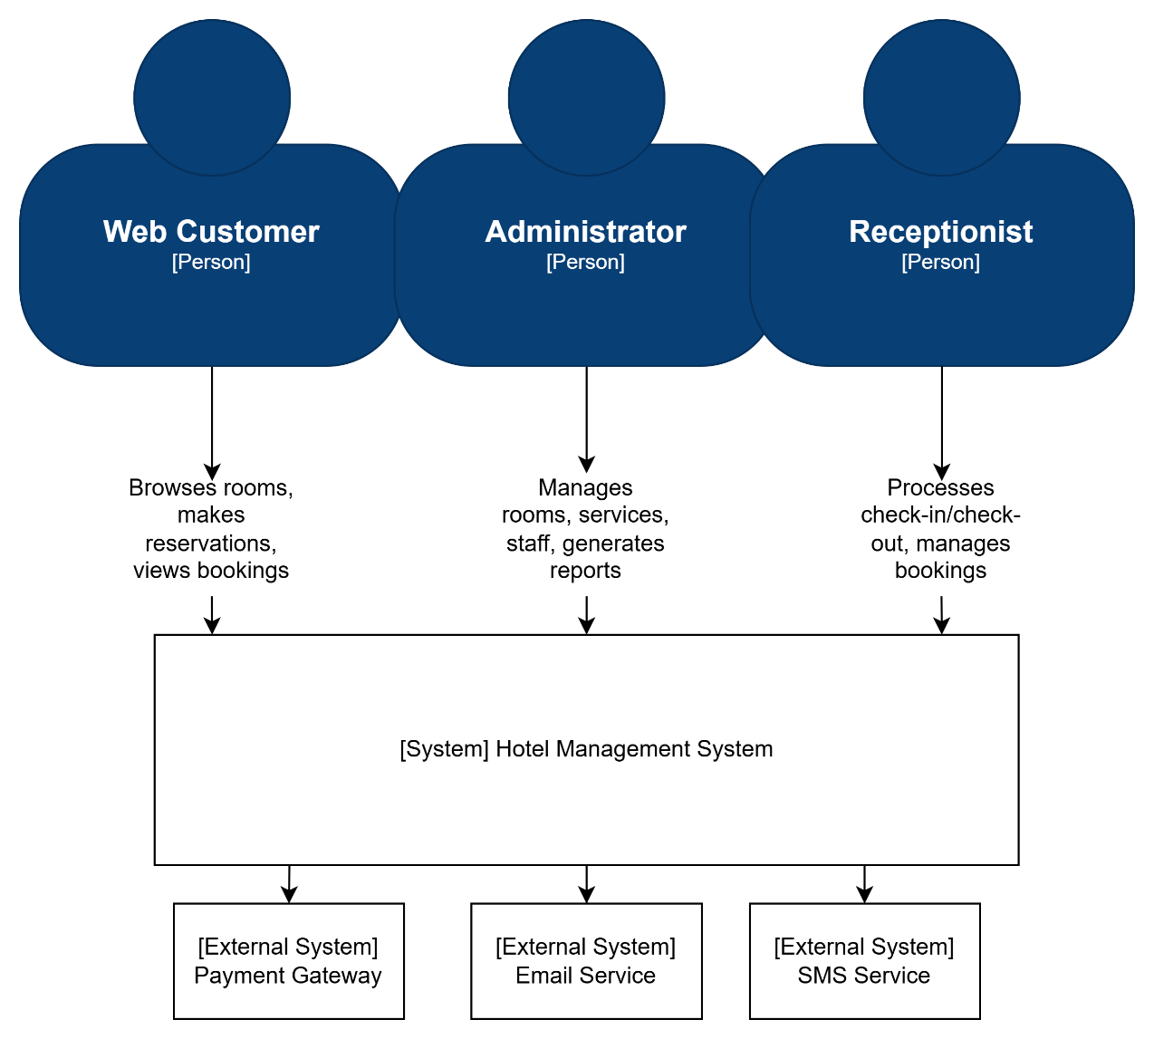

Figure 2: C4 lv 1 Diagram
At the center of the model is the Hotel Management System, a single Flask-based monolithic backend with a static web UI. Around this system boundary are three primary human actors:
- Web Customer: browses rooms, creates and manages bookings, performs payments, manages wallet balance, and submits service requests or contact messages.
- Receptionist: manages daily hotel operations such as check-in/check-out, walk‑in bookings, room assignment, and monitoring of transactions and service requests.
- Administrator: manages room inventory, services, staff accounts, user accounts, and analytical reports.
All interactions from these actors go through the web browser UI into the monolithic backend, which in turn persists state in a single MySQL database. External services such as third‑party payment gateways or email providers are considered future integrations but are not part of the current implementation.
C4 Level 2 - Container Diagram
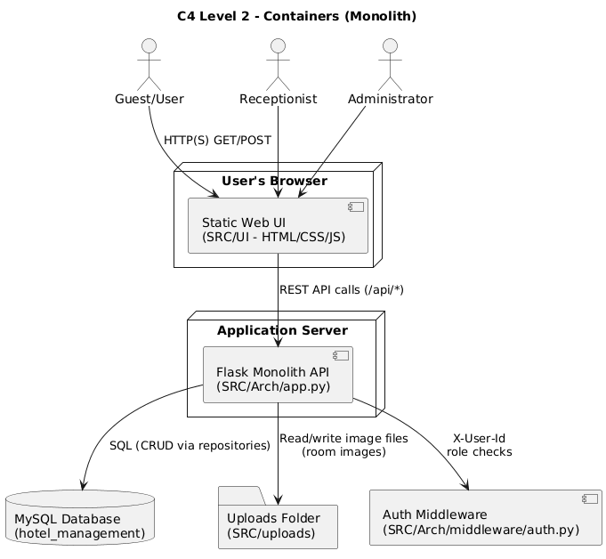

Figure 3: C4 lv 2 - Container Diagram
At the container level, the Hotel Management System is decomposed into three main containers:
- Web Browser (Static Web UI – SRC/UI): HTML/CSS/JavaScript pages grouped by role (public, auth, user, admin, receptionist). JavaScript (notably api.js) calls backend APIs under /api/ and renders booking, wallet, payment, and management screens.
- Flask Monolith API (SRC/Arch): a single Flask application (app.py) exposing REST‑style JSON endpoints for rooms, bookings, payments, coupons, wallet, service requests, staff, reports, and authentication. It implements all business rules and orchestrates database access.
- MySQL Database: the relational store for users, rooms, bookings, payments, wallets, coupons, service requests, staff, and reports, configured via SRC/Arch/db_config.py.
Static file storage for uploaded room images (SRC/uploads/rooms) is also modeled as an infrastructure container, served via the /uploads/<filename> route from the Flask monolith. The browser communicates only with the Flask API and /uploads/; the API is the single integration point to MySQL and the uploads storage.
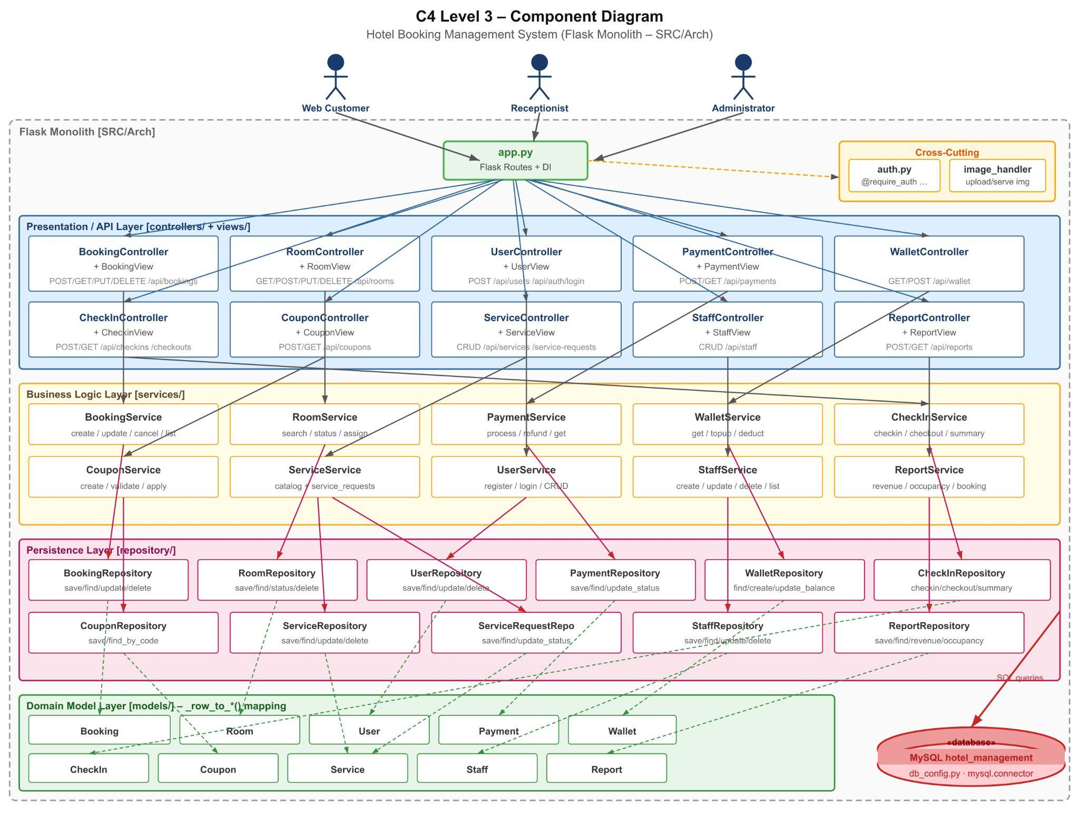
C4 Level 3 - Components Diagram

Figure 4: C4 lv 3 - Components Diagram

Inside the Flask monolith, the main components are organized into layers:
- Routing / Entry Point: app.py defines Flask routes and wires them to controller methods. It also applies authentication/authorization decorators from middleware/auth.py.
- Controllers (SRC/Arch/controllers): one controller per domain (e.g., booking_controller.py, room_controller.py, user_controller.py, payment_controller.py, coupon_controller.py, checkin_controller.py, staff_controller.py, report_controller.py, wallet_controller.py, service_controller.py). Controllers parse HTTP requests, perform basic validation, and delegate to services.
- Views (SRC/Arch/views): view classes (e.g., booking_view.py, room_view.py, payment_view.py) format domain objects and errors into consistent JSON responses.
- Services (SRC/Arch/services): business‑logic components such as booking_service.py, room_service.py, payment_service.py, wallet_service.py, coupon_service.py, service_service.py, checkin_service.py, staff_service.py, report_service.py, and user_service.py. They implement booking lifecycle, availability checks, payment and refund rules, wallet updates, coupon validation, reporting, and staff/user/service management.
- Repositories (SRC/Arch/repository): data‑access components (booking_repository.py, room_repository.py, user_repository.py, payment_repository.py, wallet_repository.py, coupon_repository.py, service_repository.py, service_request_repository.py, staff_repository.py, checkin_repository.py, report_repository.py) wrapping SQL queries against MySQL.
- Domain Models (SRC/Arch/models): entity classes such as booking.py, room.py, user.py, staff.py, service.py, coupon.py, checkin.py, payment.py, wallet.py, and report.py.
- Cross‑cutting components: authentication/authorization middleware in middleware/auth.py (decorators like require_auth, require_admin, require_receptionist_or_admin) and the image upload handler in utils/image_handler.py used by room management.

C4 Level 4 - Code view Diagram
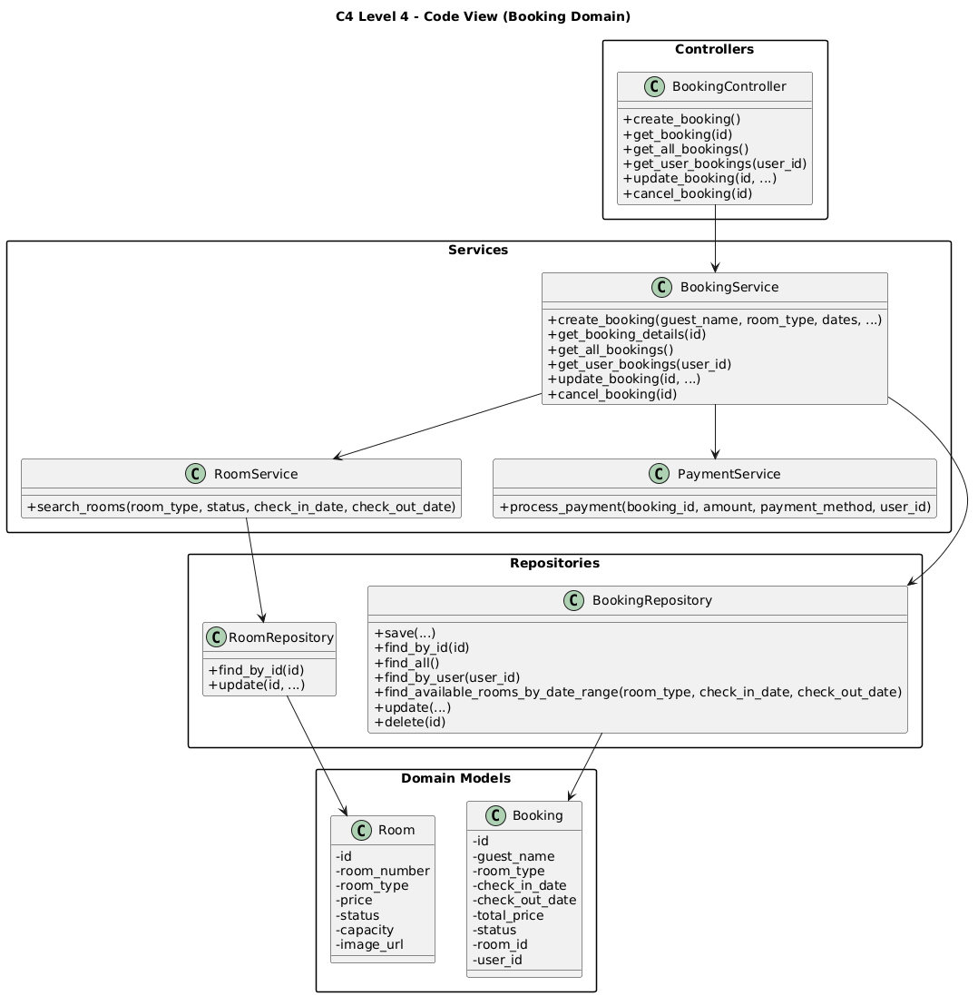
Figure 5: C4 lv 4 - Code view booking domain Diagram
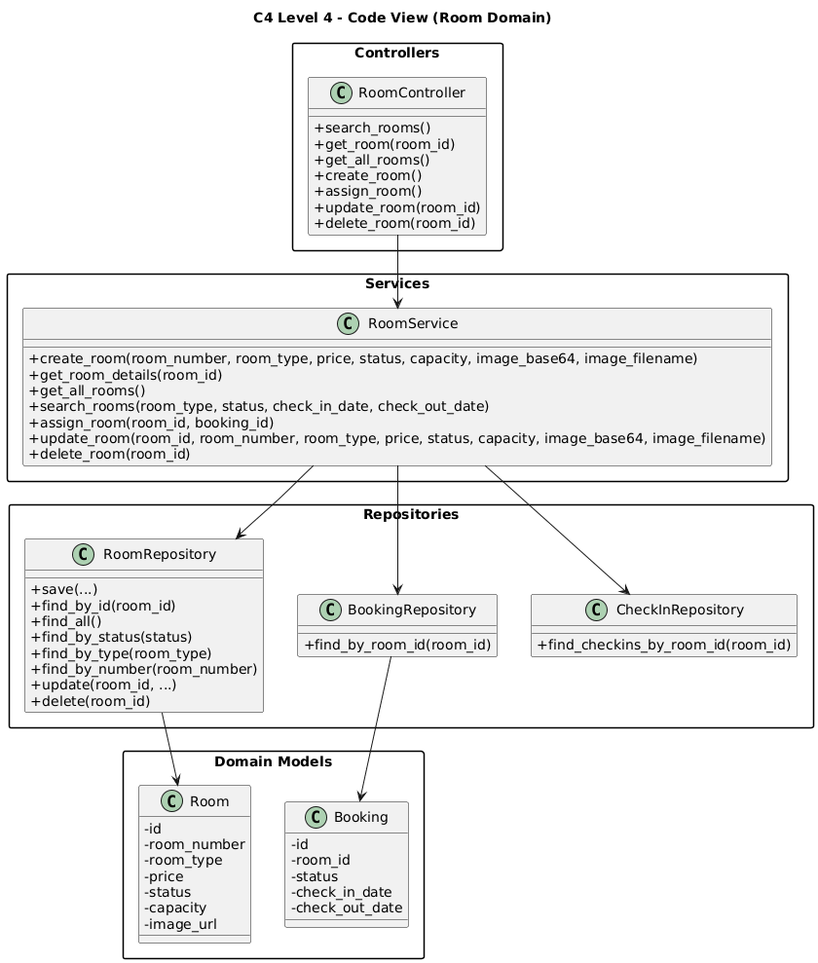
Figure 6: C4 lv 4 - Code view room domain Diagram

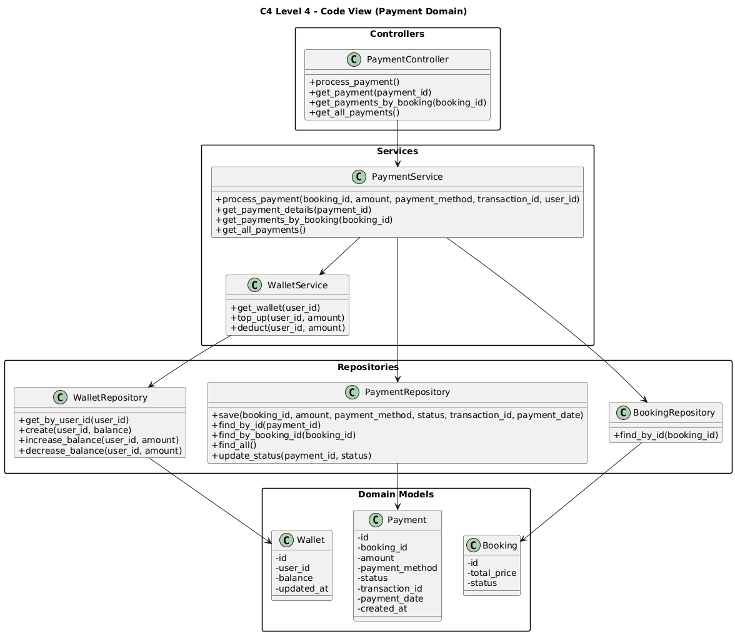

Figure 7: C4 lv 4 - Code view payment domain Diagram
At the code level, each component family is realized by a consistent set of Python modules and classes:
- Routes and composition: SRC/Arch/app.py imports all controllers, registers Flask routes (e.g., /api/bookings, /api/rooms, /api/payments), and applies middleware decorators. This file is the concrete entry point shown in the code‑level diagram.
- Domain slices: for each domain (booking, room, payment, wallet, coupon, service requests, staff, reports, users, check‑in/out) there is a cohesive group of modules following the pattern: controllers/<domain>_controller.py ↔ services/<domain>_service.py ↔ repository/<domain>_repository.py ↔ models/<Domain>.py ↔ views/<domain>_view.py. For example, booking_controller.py, booking_service.py, booking_repository.py, booking.py, and booking_view.py together implement the booking slice.
- Infrastructure code: db_config.py configures MySQL connections; middleware/auth.py implements authentication and RBAC; utils/image_handler.py handles file uploads; SRC/UI/js/api.js encapsulates frontend HTTP calls to the backend.

This code‑level perspective makes it clear how the high‑level C4 components map directly to concrete packages, modules, and classes in the repository, and supports the architectural goals described in the ASRs (modifiability, maintainability, performance, and security).

2.2 Technical Stack and Data Model
Technical Stack:
- Backend Framework: Flask (Python) – used to define routes in app.py and integrate controllers, services, and middleware.
- CORS: flask_cors.CORS configured to allow frontend (likely served from a different origin) to access /api/ and /uploads/.
- Database: MySQL, configured via SRC/Arch/db_config.py. The DatabaseConfig class uses environment variables (DB_HOST, DB_PORT, DB_NAME, DB_USER, DB_PASSWORD) loaded from .env to create connections using mysql.connector.
- Data Access Pattern: Repositories use explicit SQL queries to interact with tables. For example, BookingRepository.save inserts into bookings and returns a Booking object.
- Frontend: Static HTML/CSS/JS in SRC/UI (index.html, rooms.html, room-detail.html, auth/login.html, auth/register.html, user/dashboard.html, user/my-bookings.html, user/payment.html, user/wallet.html, admin/admin.html, admin/receptionist.html, etc.).
- Static & Uploaded Content: SRC/UI/images contains UI images; SRC/uploads/rooms stores uploaded room images. app.py serves uploaded files via the /uploads/<path:filename> route (e.g., /uploads/rooms/<image>.jpg)..

Data Model:
- Room: id, room_number, room_type, price, status, capacity, image_url.
- Booking: id, user_id, guest_name, room_type, room_id, check_in_date, check_out_date, total_price, status, created_at, updated_at.
- User: id, name, email, password_hash, role (user, receptionist, admin), etc.
- Payment: id, booking_id, user_id, amount, payment_method (cash, wallet, etc.), status (pending, completed, refunded), created_at.
- Wallet: id, user_id, balance, created_at, updated_at.
- Coupon: id, code, discount_type (percentage/fixed_amount), discount_value, valid_from, valid_to, is_active.
- CheckIn: id, booking_id, room_id, check_in_time, check_out_time, status.
- Report: id, type (revenue/occupancy/booking), parameters (e.g., date range), generated_at, content/summary fields.

2.2.1 Data Relationships
ER Diagram

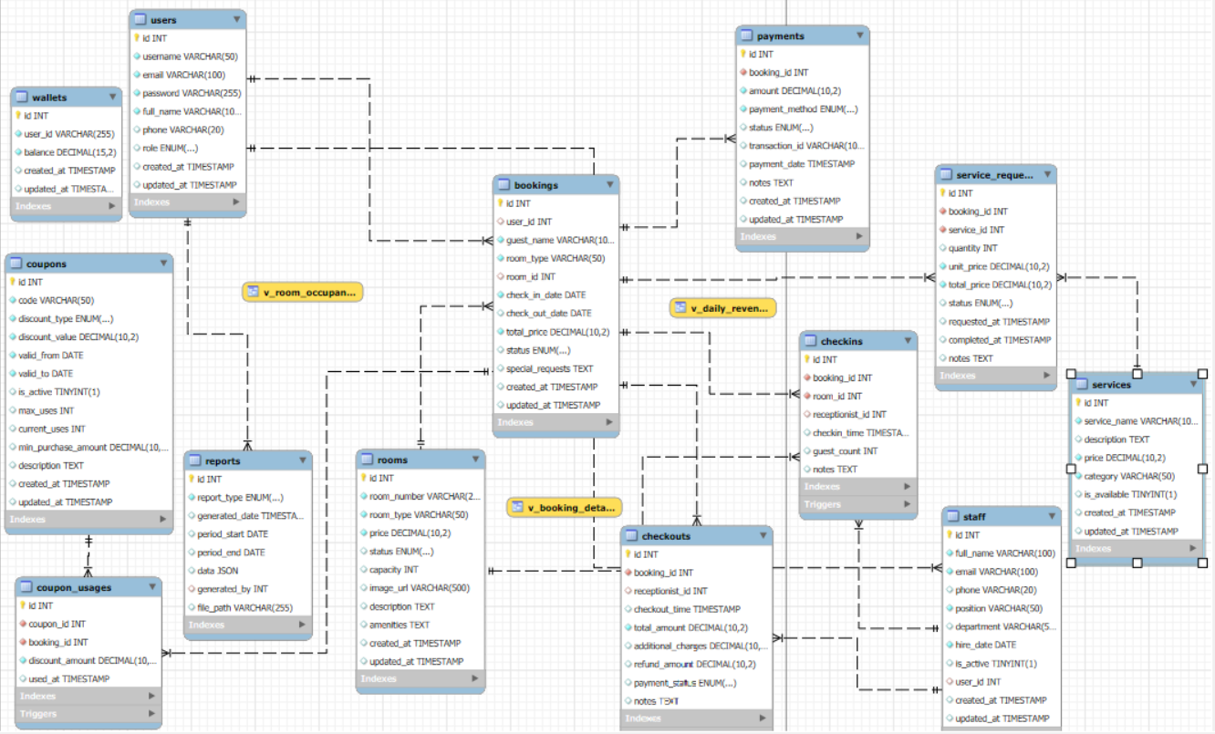

Figure 8: ER Diagram

Users table:
ID | Data Object | Field name | Description | Unique? | Data type | Length | Req’d?
US1 | users | id | User auto-increment ID | Y | int | 11 | Y
US2 | users | username | Login ID | Y | varchar | 50 | Y
US3 | users | email | User's Email | Y | varchar | 100 | Y
US4 | users | password | Encrypted password | N | varchar | 255 | Y
US5 | users | full_name | User’s full name | N | varchar | 100 | Y
US6 | users | phone | User’s phone number | N | varchar | 20 | N
US7 | users | role | User role | N | enum | – | Y
US8 | users | created_at | Created at | N | timestamp | – | Y
US9 | users | updated_at | Updated at | N | timestamp | – | Y

Staff table:
ID | Data Object | Field name | Description | Unique? | Data type | Length | Req’d?
ST1 | staff | id | Staff ID | Y | int | 11 | Y
ST2 | staff | full_name | Staff’s full name | N | varchar | 100 | Y
ST3 | staff | email | User’s email | Y | varchar | 100 | Y
ST4 | staff | phone | Phone number | N | varchar | 20 | N
ST5 | staff | position | position | N | varchar | 50 | Y
ST6 | staff | department | department | N | varchar | 50 | N
ST7 | staff | hire_date | Hire date | N | date | – | Y
ST8 | staff | is_active | Working Status | N | boolean | – | Y
ST9 | staff | user_id | FK → users.id | N | int | 11 | N
ST10 | staff | created_at | Created at | N | timestamp | – | Y
ST11 | staff | updated_at | Updated at | N | timestamp | – | Y

Rooms table:
ID | Data Object | Field name | Description | Unique? | Data type | Length | Req’d?
RM1 | rooms | id | Room ID | Y | int | 11 | Y
RM2 | rooms | room_number | Room number | Y | varchar | 20 | Y
RM3 | rooms | room_type | Room type | N | varchar | 50 | Y
RM4 | rooms | price | Room price | N | decimal | 10,2 | Y
RM5 | rooms | status | Room status | N | enum | – | Y
RM6 | rooms | capacity | Capacity | N | int | 11 | N
RM7 | rooms | image_url | Room’s picture | N | varchar | 500 | N
RM8 | rooms | description | Description | N | text | – | N
RM9 | rooms | amenities | amenities | N | text | – | N
RM10 | rooms | created_at | Created at | N | timestamp | – | Y
RM11 | rooms | updated_at | Updated at | N | timestamp | – | Y

Bookings table:
ID | Data Object | Field name | Description | Unique? | Data type | Length | Req’d?
BK1 | bookings | id | Booking ID | Y | int | 11 | Y
BK2 | bookings | user_id | FK → users.id | N | int | 11 | N
BK3 | bookings | guest_name | User’ name | N | varchar | 100 | Y
BK4 | bookings | room_type | Requested Room Type | N | varchar | 50 | Y
BK5 | bookings | room_id | FK → rooms.id | N | int | 11 | N
BK6 | bookings | check_in_date | Checkin date | N | date | – | Y
BK7 | bookings | check_out_date | Checkout date | N | date | – | N
BK8 | bookings | total_price | Total price | N | decimal | 10,2 | Y
BK9 | bookings | status | Booking status | N | enum | – | Y
BK10 | bookings | special_requests | Special requests | N | text | – | N
BK11 | bookings | created_at | Created at | N | timestamp | – | Y
BK12 | bookings | updated_at | Updated at | N | timestamp | – | Y

Payments table:
ID | Data Object | Field name | Description | Unique? | Data type | Length | Req’d?
PM1 | payments | id | Payment ID | Y | int | 11 | Y
PM2 | payments | booking_id | FK → bookings.id | N | int | 11 | Y
PM3 | payments | amount | amount | N | decimal | 10,2 | Y
PM4 | payments | payment_method | Payment method | N | enum | – | Y
PM5 | payments | status | status | N | enum | – | Y
PM6 | payments | transaction_id | Transaction ID | N | varchar | 100 | N
PM7 | payments | payment_date | Payment date | N | timestamp | – | N
PM8 | payments | notes | notes | N | text | – | N

Services table:
ID | Data Object | Field name | Description | Unique? | Data type | Length | Req’d?
SV1 | services | id | Services ID | Y | int | 11 | Y
SV2 | services | service_name | Service name | N | varchar | 100 | Y
SV3 | services | description | description | N | text | – | N
SV4 | services | price | price | N | decimal | 10,2 | Y
SV5 | services | category | category | N | varchar | 50 | Y
SV6 | services | is_available | Service status | N | boolean | – | Y

Service requests table:
ID | Data Object | Field name | Description | Unique? | Data type | Length | Req’d?
SR1 | service_requests | id | Service requests ID | Y | int | 11 | Y
SR2 | service_requests | booking_id | FK → bookings.id | N | int | 11 | Y
SR3 | service_requests | service_id | FK → services.id | N | int | 11 | Y
SR4 | service_requests | quantity | quantity | N | int | 11 | Y
SR5 | service_requests | unit_price | Unit price | N | decimal | 10,2 | Y
SR6 | service_requests | total_price | Total price | N | decimal | 10,2 | Y
SR7 | service_requests | status | service status | N | enum | – | Y

Coupons table:
ID | Data Object | Field name | Description | Unique? | Data type | Length | Req’d?
CP1 | coupons | id | Coupon ID | Y | int | 11 | Y
CP2 | coupons | code | Coupon code | Y | varchar | 50 | Y
CP3 | coupons | discount_type | coupons discount type | N | enum | – | Y
CP4 | coupons | discount_value | Coupons discount value | N | decimal | 10,2 | Y
CP5 | coupons | valid_from | Coupons valid from | N | date | – | Y
CP6 | coupons | valid_to | Coupons valid to | N | date | – | Y
CP7 | coupons | is_active | Coupons status | N | boolean | – | Y

Coupon usages table:
ID | Data Object | Field name | Description | Unique? | Data type | Length | Req’d?
CU1 | coupon_usages | id | Coupon usages ID | Y | int | 11 | Y
CU2 | coupon_usages | coupon_id | FK → coupons.id | N | int | 11 | Y
CU3 | coupon_usages | booking_id | FK → bookings.id | N | int | 11 | Y
CU4 | coupon_usages | discount_amount | Coupon usages discount amount | N | decimal | 10,2 | Y
CU5 | coupon_usages | used_at | Coupon usages used at | N | timestamp | – | Y

Checkins table:
ID | Data Object | Field name | Description | Unique? | Data type | Length | Req’d?
CI1 | checkins | id | check-in ID | Y | int | 11 | Y
CI2 | checkins | booking_id | FK → bookings.id | Y | int | 11 | Y
CI3 | checkins | room_id | FK → rooms.id | N | int | 11 | Y
CI4 | checkins | receptionist_id | FK → staff.id | N | int | 11 | N
CI5 | checkins | checkin_time | Checkin time | N | timestamp | – | Y

Checkouts table:
ID | Data Object | Field name | Description | Unique? | Data type | Length | Req’d?
CO1 | checkouts | id | Checkout ID | Y | int | 11 | Y
CO2 | checkouts | booking_id | FK → bookings.id | Y | int | 11 | Y
CO3 | checkouts | receptionist_id | FK → staff.id | N | int | 11 | N
CO4 | checkouts | checkout_time | Checkout time | N | timestamp | – | Y
CO5 | checkouts | total_amount | Total amount | N | decimal | 10,2 | Y

Wallets table:
ID | Data Object | Field name | Description | Unique? | Data type | Length | Req’d?
WL1 | wallets | id | Wallets ID | Y | int | 11 | Y
WL2 | wallets | user_id | FK → users.id | Y | int | 11 | Y
WL3 | wallets | balance | balance | N | decimal | 15,2 | Y

Reports table:
ID | Data Object | Field name | Description | Unique? | Data type | Length | Req’d?
RP1 | reports | id | Reports ID | Y | int | 11 | Y
RP2 | reports | report_type | Report type | N | enum | – | Y
RP3 | reports | generated_date | Generated date | N | timestamp | – | Y
RP4 | reports | period_start | Period start | N | date | – | N
RP5 | reports | period_end | Period end | N | date | – | N
RP6 | reports | data | Reports data | N | json | – | N
RP7 | reports | generated_by | FK → users.id | N | int | 11 | N
RP8 | reports | file_path | File path | N | varchar | 255 | N

2.2.2 Key State Models (Status Transitions)
Booking status (typical):
• pending → checked_in → checked_out
• pending → cancelled
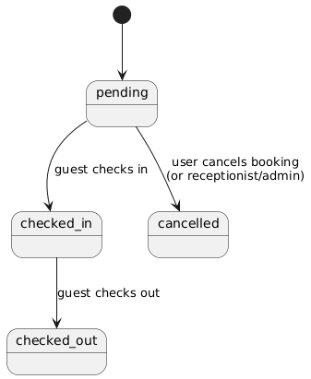

Figure 9: Key state booking status
Room status (typical):
• available → reserved → occupied → available (or dirty/maintenance depending on policy)
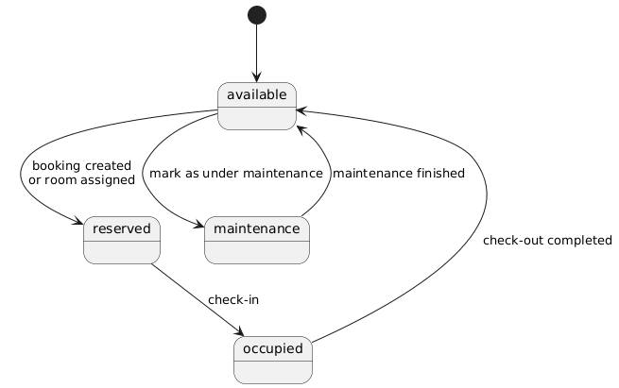

Figure 10: Key state room status
Payment status (typical):
• pending → completed → refunded (if cancellation/refund occurs)
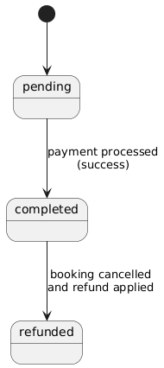
Figure 11: Key state payment status

2.2.3 API Endpoint Catalog (Core Contracts)
The following list documents the public API contracts of the monolith (grouped by domain).

Booking api:
Method | Endpoint | Auth | Role | Describe
POST | /api/bookings | Yes | user / receptionist / admin | Create booking
GET | /api/bookings/my | Yes | user / receptionist / admin | Get current user's bookings
GET | /api/bookings | Yes | receptionist / admin | Get all bookings
GET | /api/bookings/{booking_id} | Yes | user / receptionist / admin | Booking Details
PUT | /api/bookings/{booking_id} | Yes | receptionist / admin | Update Booking
DELETE | /api/bookings/{booking_id} | Yes | user / receptionist / admin | Cancel booking

Rooms api:
Method | Endpoint | Auth | Role | Describe
GET | /api/rooms | Optional | – | Room List
GET | /api/rooms/search | Optional | – | Filter Rooms by Type/Status
GET | /api/rooms/{room_id} | Optional | – | Room Details
POST | /api/rooms | Yes | admin | Create Room
PUT | /api/rooms/{room_id} | Yes | admin | Update room
DELETE | /api/rooms/{room_id} | Yes | admin | Delete room
POST | /api/rooms/assign | Yes | receptionist / admin | Assign Room
GET | /uploads/{filename} | Public | – | Return Image URL

Auth & User api:
Method | Endpoint | Auth | Role | Describe
POST | /api/auth/login | Public | – | Login
POST | /api/users | Public | – | Register
GET | /api/users | Yes | admin | User List
GET | /api/users/{user_id} | Yes | user / receptionist / admin | User Details
PUT | /api/users/{user_id}/profile | Yes | user / receptionist / admin | Update Profile
PUT | /api/users/{user_id} | Yes | admin | Admin Update User
DELETE | /api/users/{user_id} | Yes | admin | Delete User

Services & Service requests:
Method | Endpoint | Auth | Role | Describe
GET | /api/services | Optional | – | Service List
GET | /api/services/{service_id} | Optional | – | Service Details
POST | /api/services | Yes | admin | Create Service
PUT | /api/services/{service_id} | Yes | admin | Update Service
DELETE | /api/services/{service_id} | Yes | admin | Delete Service
POST | /api/services/request | Yes | user / receptionist / admin | Create Service Request
GET | /api/service-requests | Yes | receptionist / admin | Service requests  list
GET | /api/service-requests/{request_id} | Yes | receptionist / admin | Request List
PUT | /api/service-requests/{request_id} | Yes | receptionist / admin | Request Details

Payments:
Method | Endpoint | Auth | Role | Describe
POST | /api/payments | Yes | user / receptionist / admin | Payments
GET | /api/payments | Yes | receptionist / admin | Transaction History
GET | /api/payments/{payment_id} | Yes | user / receptionist / admin | Payment Details
GET | /api/bookings/{booking_id}/payments | Yes | user / receptionist / admin | Payment by Booking

Coupons:
Method | Endpoint | Auth | Role | Describe
POST | /api/coupons | Yes | admin | Create coupon
GET | /api/coupons/{coupon_id} | Optional | – | Coupon detail
POST | /api/coupons/apply | Yes | user / receptionist / admin | Apply coupon

Check out:
Method | Endpoint | Auth | Role | Describe
POST | /api/checkins | Yes | receptionist / admin | Check-in
POST | /api/checkouts | Yes | receptionist / admin | Check-out
GET | /api/checkins/{checkin_id} | Yes | receptionist / admin | check-in detail
GET | /api/checkouts/summary/  {booking_id} | Yes | user / receptionist / admin | Checkout Summary
Wallet:
Method | Endpoint | Auth | Role | Describe
GET | /api/wallet | Yes | user / receptionist / admin | wallet
POST | /api/wallet/topup | Yes | user / receptionist / admin | Top-up Wallet
Staff:
Method | Endpoint | Auth | Role | Describe
GET | /api/staff | Yes | admin | Staff list
POST | /api/staff | Yes | admin | Create staff
GET | /api/staff/{staff_id} | Yes | admin | Staff detail
PUT | /api/staff/{staff_id} | Yes | admin | Update staff
DELETE | /api/staff/{staff_id} | Yes | admin | Delete staff
Reports:
Method | Endpoint | Auth | Role | Describe
POST | /api/reports/revenue | Yes | admin | Revenue Report
POST | /api/reports/occupancy | Yes | admin | Occupancy Report
POST | /api/reports/booking | Yes | admin | Booking Report
GET | /api/reports/{report_id} | Yes | admin | Report detail
GET | /api/reports/type/{report_type} | Yes | admin | Report by Category

2.2.4 Authorization Matrix (Role-based Access Control Summary)
- Public (no auth): /api/auth/login, /api/users (register), /uploads/*
- Optional auth (guest can access): GET /api/rooms*, GET /api/services*, GET /api/coupons/<id>
- User: booking create/cancel/view own, payments by booking, wallet, request service, apply coupon
- Receptionist: booking list/update, assign room, check-in/check-out, manage service requests, payment list
- Administrator: all receptionist permissions + full CRUD for rooms/services/users/staff + reports + coupons

2.3 Implementation: Server-Side Logic (Flask Backend – Controllers/Services)
Example: Booking Creation Flow
1. The frontend (e.g., from rooms.html or room-detail.html) sends a POST request to /api/bookings with JSON body containing:
- guest_name
- room_type
- check_in_date (and optionally check_out_date)
- optional total_price override
- optional payment_method and payment_amount
2. app.py defines the route:
- @app.route('/api/bookings', methods=['POST']) @require_auth def create_booking(): return booking_controller.create_booking()
3. BookingController.create_booking() reads request.json, obtains the current user from request.current_user (set by the authentication middleware), and calls BookingService.create_booking(...).
4. BookingService.create_booking() performs:
- Input validation (guest name, room type, dates).
- Date parsing and validation (no past check-in, check-out after check-in).
- Room availability check by calling RoomService.search_rooms(..., check_in_date, check_out_date). This uses BookingRepository.find_available_rooms_by_date_range() to exclude rooms with overlapping bookings.
- Room selection (first available) and status update to "reserved" via RoomRepository.
- Booking creation via BookingRepository.save(...) within a transaction.
- Optional payment processing by calling PaymentService.process_payment(...) if payment details were provided. If payment fails, the service releases the room and cancels the booking.
5. BookingController then uses BookingView.booking_created(booking) to format a JSON response including booking details for the frontend.

Example: Booking Cancellation & Refund Flow
1. The frontend sends DELETE /api/bookings/<booking_id>, which is protected by
@require_auth in app.py.
2. BookingController.cancel_booking(booking_id) calls BookingService.cancel_booking.
3. BookingService.cancel_booking:
- Validates that the booking exists and is not already checked_in, checked_out,
or cancelled.
- Ensures there is no check-in record (via CheckInRepository).
- Releases the room by setting its status back to "available" if it was "reserved".
- Looks up completed payments for the booking through PaymentService and, if applicable, refunds the amount to the user’s wallet and updates payment status to "refunded".
- Updates booking status to "cancelled" via BookingRepository.delete (which sets
status = 'cancelled').
4. A descriptive message is returned to the client, including refund notes if any.

Example: Coupon Application Flow
1. The frontend sends POST /api/coupons/apply with a coupon code.
2. CouponController.apply_coupon() calls CouponService.apply_coupon(code).
3. CouponService.apply_coupon:
- Loads the coupon by code via CouponRepository.
- Validates that the coupon exists and is active.
- Checks current date against coupon.valid_from and coupon.valid_to, ensuring The coupon is neither expired nor not yet valid.
- Returns coupon details to the controller, which then responds with discount information so that the frontend can adjust the total price.

Example: Payment Processing Flow
1. Frontend sends POST /api/payments with JSON:
- booking_id, amount, payment_method (credit_card/cash/bank_transfer), optional user_id context.
2. PaymentController.process_payment delegates to PaymentService.process_payment(...).
3. PaymentService validates:
- amount > 0; payment_method in allowed methods; booking exists and not cancelled.
4. If wallet-based payment is used in the current design, the service checks wallet balance and deducts.
5. PaymentRepository saves payment records (status pending/completed).
6. Backend returns payment result to the frontend.

Example: Check-in Flow (Receptionist)
1. The receptionist selects a booking and calls POST /api/checkins (booking_id, receptionist_id, optional room_id).
2. CheckInController delegates to CheckInService.process_checkin(...).
3. Service validates booking exists, not already checked in, and room assignment matches booking.room_type.
4. Repository saves check-in records and service updates booking status to checked_in and room status to occupied.
5. Backend returns the check-in record.

Example: Check-out Flow (Receptionist)
1. The receptionist calls POST /api/checkouts with booking_id and checkout details.
2. CheckInService validates that a check-in exists for the booking.
3. Service calculates total checkout amount:
- room cost (booking.total_price) + additional services (service_requests total).
4. Repository saves checkout record; service updates booking status to checked_out and releases/updates room status.
5. Backend returns checkout result; user can view summary via GET /api/checkouts/summary/<booking_id>.

Example: Service Request Flow
1. User requests a service via POST /api/services/request (booking_id, service_id, quantity).
2. ServiceController delegates to ServiceService.create_service_request(...).
3. ServiceService validates booking exists and service exists, then creates service_requests record.
4. Receptionist/Admin can view and manage requests via:
- GET /api/service-requests, GET /api/service-requests/<id>, PUT /api/service-requests/<id>.

Example: Wallet Flow
1. User opens wallet page → GET /api/wallet.
2. WalletService returns wallet; if missing, creates one with balance 0.
3. User tops up → POST /api/wallet/topup with amount; system validates numeric and > 0, then updates balance.

2.3.1 Key Validation & Error Handling Strategy
Input validation is primarily implemented in the Service layer (e.g., BookingService, PaymentService, CouponService):
- Date validation: YYYY-MM-DD; check-in not in past; check-out after check-in.
- Money validation: amount > 0; discounts within valid ranges.
- State validation: cannot cancel/update after check-in; cannot checkout without check-in.
- Role validation: enforced by middleware decorators (401/403).

Error Response Strategy (high-level):
- 400 Bad Request: invalid input data, business rule violation
- 401 Unauthorized: authentication required / missing X-User-Id
- 403 Forbidden: role not permitted
- 404 Not Found: resource not found (booking/room/service/coupon/etc.)
- 500 Internal Server Error: database or unexpected server errors

2.3.2 Runtime/Deployment View
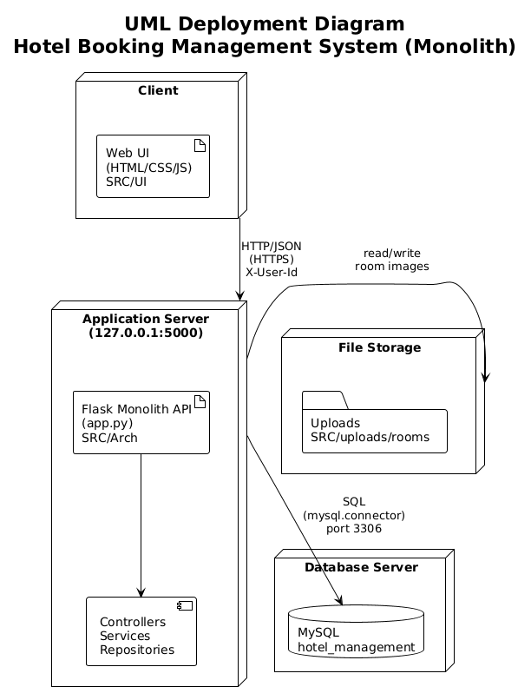
Figure 12: Deployment View
- The monolith runs as a single Flask process (default: 127.0.0.1:5000).
- The MySQL database is a separate process/service configured by environment variables in .env.
- UI files under SRC/UI are static and call APIs under /api/* via JavaScript (fetch).
- Uploaded images are stored under SRC/uploads and served through /uploads/<path>.

2.4 Implementation: Client-Side Logic (Web UI – HTML/CSS/JS)
The UI in SRC/UI is separated by role and page:
Public & User pages:
- index.html: homepage introducing the hotel and quick access to room browsing.
- public/rooms.html and public/room-detail.html: room list and details pages.
- user/dashboard.html: user overview, showing relevant booking and wallet info.
- user/my-bookings.html: history and status of user’s bookings.
- user/payment.html: payment UI for a specific booking.
- user/wallet.html: wallet balance, top-up form, and transaction history view
(if implemented).

Authentication pages:
- auth/login.html and auth/register.html: forms that send login/registration requests to /api/auth/login and /api/users.

Staff & Admin pages:
- admin/admin.html: admin dashboard for managing rooms, staff, services, coupons, and viewing reports.
- admin/receptionist.html: interface tailored to receptionist tasks like managing arrivals, check-ins, check-outs, and service requests.
- admin/admin-messages.html: page for internal messages or notifications.

JavaScript files (SRC/UI/js):
- api.js: centralizes AJAX/fetch calls to backend APIs; likely wraps GET/POST/PUT/DELETE requests for rooms, bookings, payments, coupons, wallet, etc.
- auth.js: handles storing auth tokens, sending login/register forms, and updating the UI based on user authentication state.
- admin.js and receptionist.js: contain logic to populate admin/receptionist tables, call backend endpoints (/api/rooms, /api/service-requests, /api/staff, /api/reports), and react to user actions (create room, accept service request, etc.).
- script.js and language.js: implement shared UI functionalities (menu behavior, language switching), while admin-messages.js and chat.js support additional user/admin communication features.

